NOTES / COMMENTS / DRAWINGS FROM YOUR EXPERIMENT
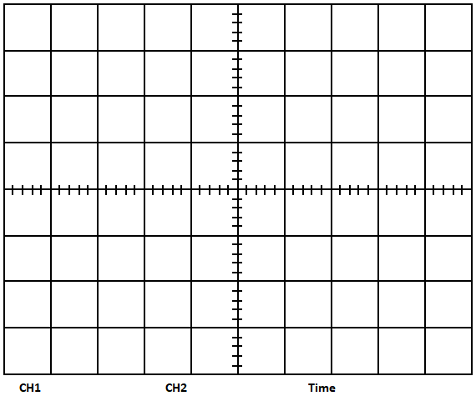
b)
c)
d)
Your comments:

e)
f) Your comments:

g)
g) Your comments:

h)
Your comments:

i)
Your comments:

m)
Your comments:
n)
Your comments:

QUESTIONS

- Draw the block diagram of Frequency Modulation/Demodulation Schema you have set up on Communication experiment kit in step h.

CONCLUSION
Write down a brief comment and conclusion about the experiment.

