NOTES / COMMENTS / DRAWINGS FROM YOUR EXPERIMENT

c)
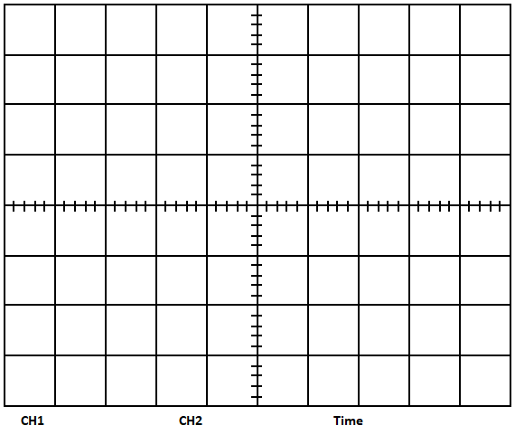

d)

e) Your comments:

g)

i)

Your comments:

Your comments:

j)

l)

m)
Your comments:

Your comments:

Your comments:

QUESTIONS

- Let the number of message signals be 4 (b=2) representing 2nd extension of binary symbols 00, 01, 10, 11. Draw an example ASK signal for the message stream 00-10-11-01-10-00.

CONCLUSION
Write down a brief comment and conclusion about the experiment.

