NOTES / COMMENTS / DRAWINGS FROM YOUR EXPERIMENT

b)
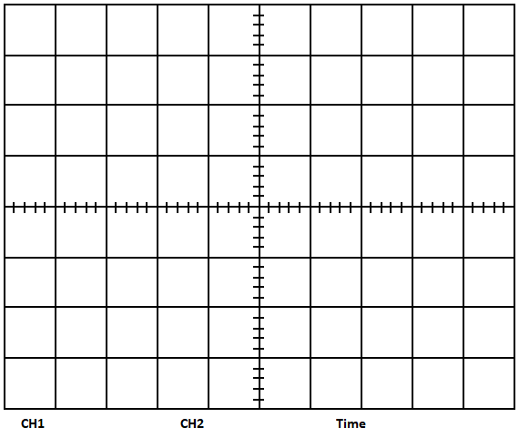

c)

d) Your comments on f_{L} and f_{H}:

f)

h)

i)

k)

l)
Your comments:

Your comments:

Your comments:

QUESTIONS

- Do you think it is possible to use more than two discrete levels for FSK modulation on this training kit? Explain.

- What is the difference between Frequency Modulation (FM) and Frequency Shift Keying (FSK)?

CONCLUSION
Write down a brief comment and conclusion about the experiment.

