NOTES / COMMENTS / DRAWINGS FROM YOUR EXPERIMENT

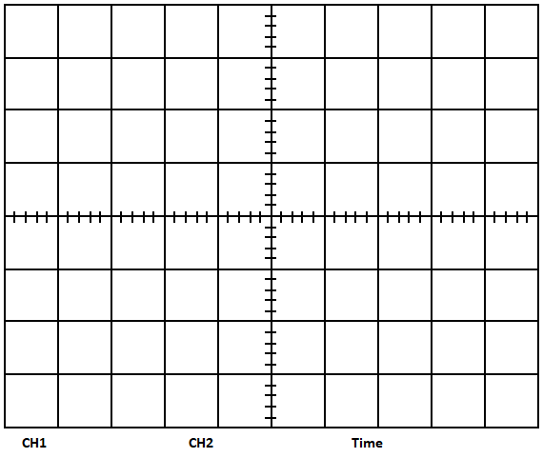

QUESTIONS

CONCLUSION
Write down a brief comment and conclusion about the experiment.

